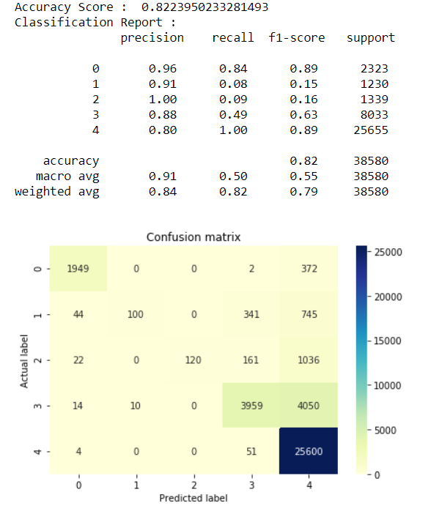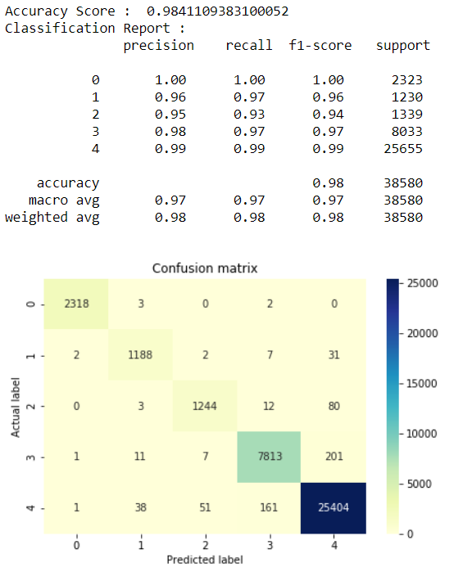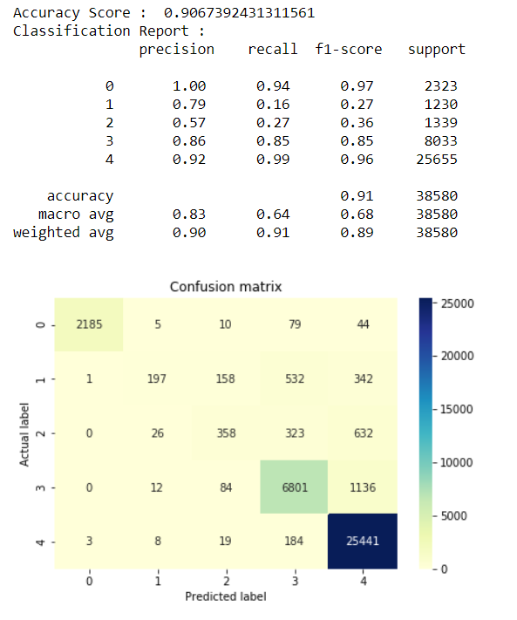

Figure : Confession Matrix of Random Forest

Figure 2: Confession Matrix of KNN

Figure 3: Confession matrix of Decision Tree